Github repo link : https://github.com/ShajithaS/GitDemo

Exercise 1:

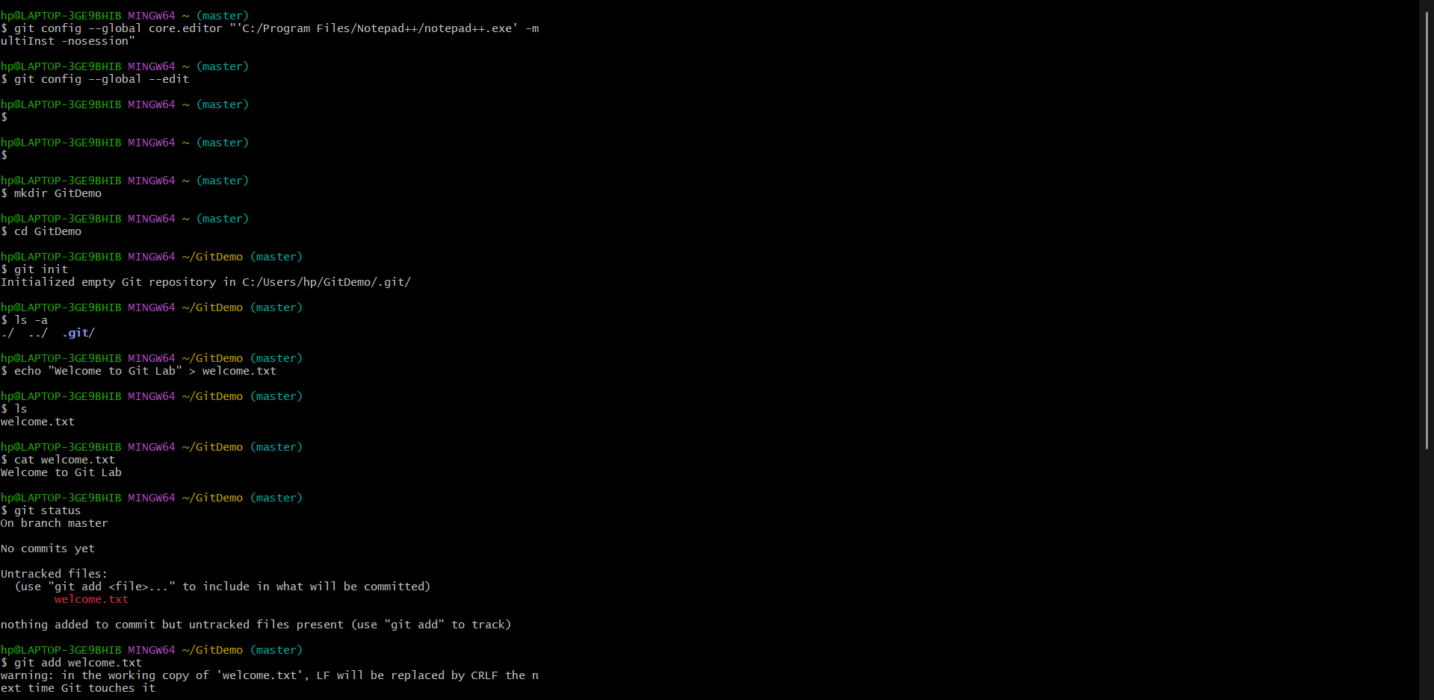

Exercise 2:

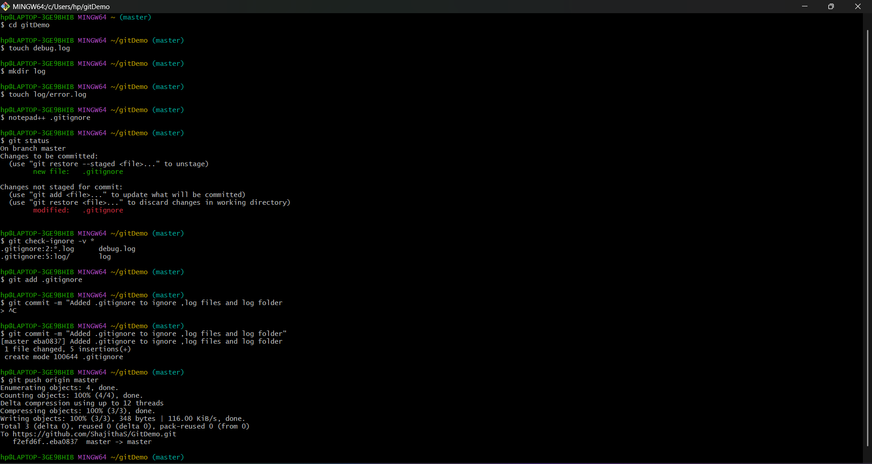

Exercise 3:

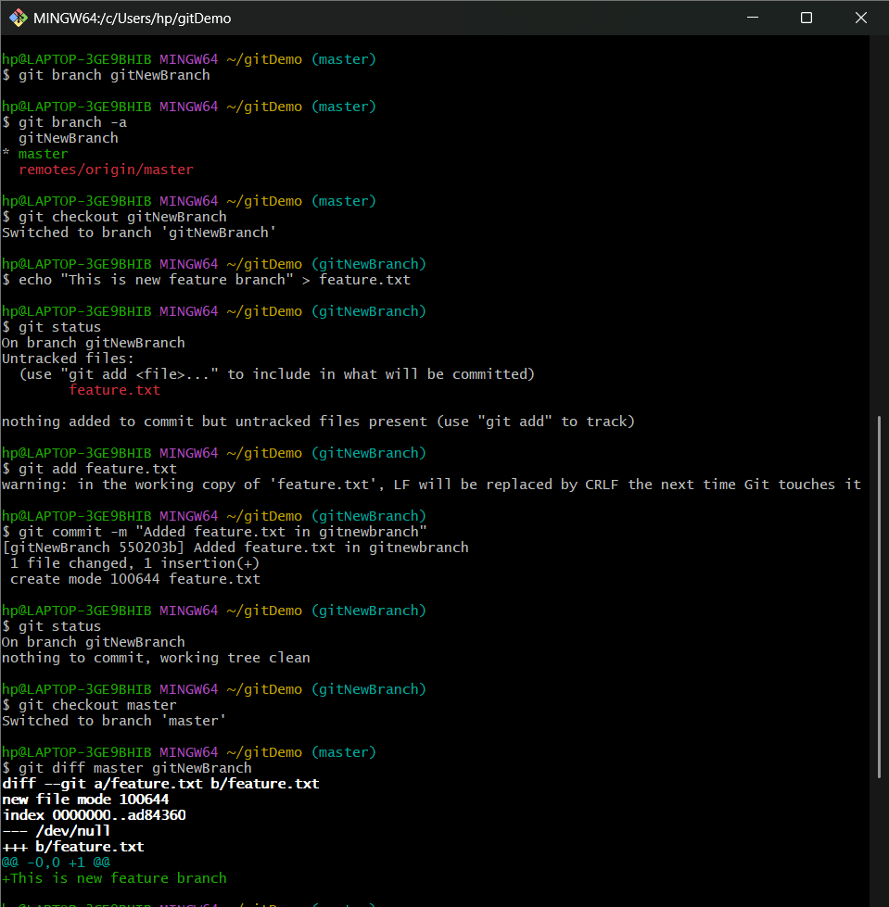

Exercise 4:

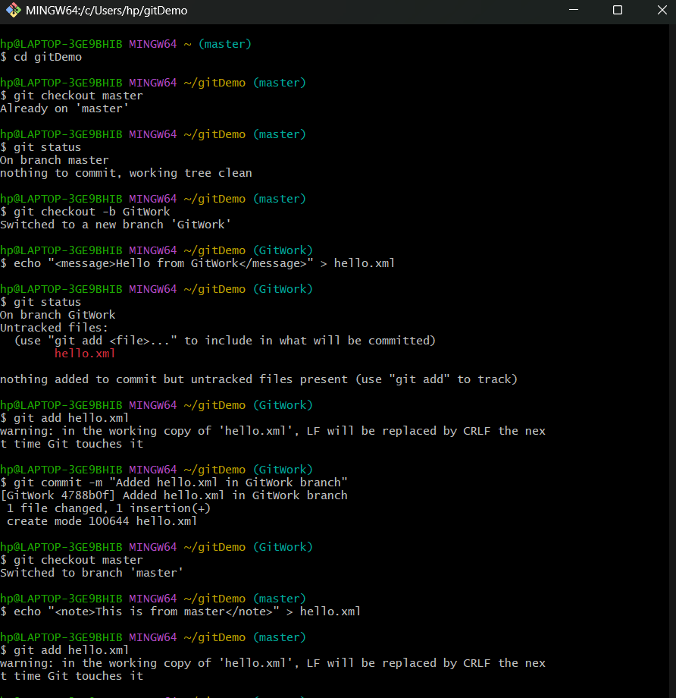

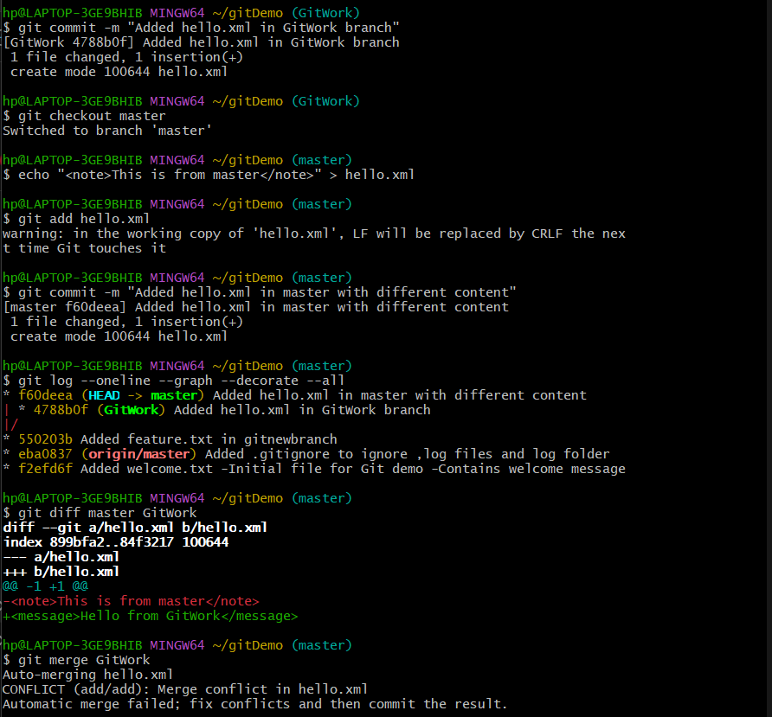

Exercise 5:

